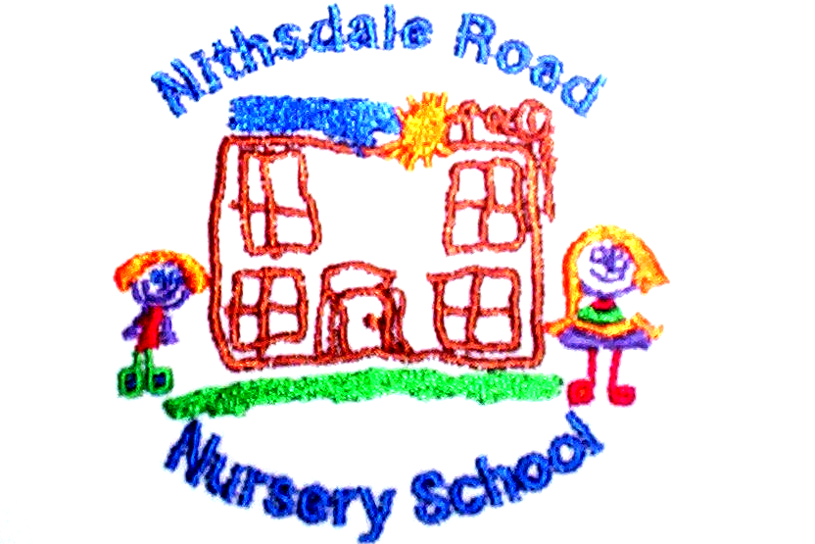


NITHSDALE ROAD NURSERY SCHOOL

264 NITHSDALE ROAD

GLASGOW

G41 5LB

TEL: 0141 427 1896

ALL ABOUT ME

Dear Parent,

At home you could extend your child’s learning by:

- talking about faces – encourage your child to look in the mirror and talk about his/her reflection – shape of face, colour of eyes, length of hair, skin tone. Ask your child to make faces showing different moods in the mirror – happy, sad, angry, afraid or surprised.

- encouraging your child to talk about his/her feelings. Comment regularly on feelings, e.g. “the little boy in the story looks angry. What do you think has happened to him to make him feel so cross?”

- When you notice how your child is feeling try naming the feeling “you feel sad because ……… . You are upset because ……… . You are angry because ……”. This is a way of listening to your child.

- ask your child, in what ways are you the same as your friends and in what way are you different to your friends? This discussion helps in the development of tolerance and understanding of differences in people, especially in connection with race and gender.

- talking about “where we live” – what is in the local area?

- talking about “keeping healthy” – taking exercise and eating the right types of food to help us stay healthy. Talk about what kind of food is good for us and what kind of food you should only eat a little of.

- talking about our senses – how do they keep us safe? e.g. seeing dangerous things, not touching hot things, hearing instructions for safety, nasty tasting things.

Active children are healthy children. The outdoors is a natural learning environment which helps to develop emotional well being. Children who are outdoors regularly are less often ill, have good concentration, they use their bodies more and have good motor skills. The best way to learn is for your child to experience things for his/herself. Children have to learn their own limits. The only way to do this is by trying and sometimes failing. Make agreements with your child and explain the consequences if he/she breaks the agreement, e.g. “you can go as far as I can see you and you can see me”.

Yours sincerely


Annemarie Miller
HEAD OF NURSERY

