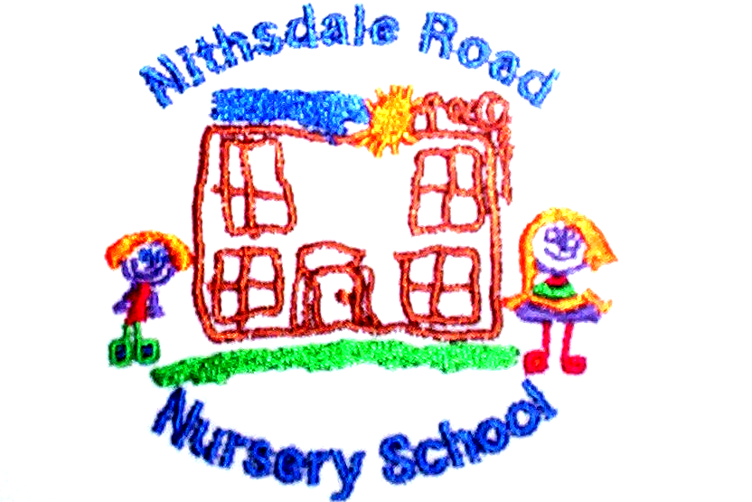


NITHSDALE ROAD NURSERY SCHOOL

264 NITHSDALE ROAD

GLASGOW

G41 5LB

TEL:0141 427 1896

EARLY NUMERACY

A GUIDE FOR PARENTS

IT’S NOT JUST ABOUT NUMBERS

The idea of mathematics for pre-school children can seem a bit daunting. However, at this age a lot of maths is about understanding ideas such as size, shape and pattern – things that most adults would not think of as maths at all. If your child gains an early understanding of these concepts, then this can give him or her a flying start with number work.

SHAPES

Give your child opportunities to notice and recognize the different shapes around them.
Use the proper names when talking to children about 3D shapes and encourage them to find things in the house with the same shape.
Look at road signs and discuss the different 2D shapes you see.

COUNTING

Children enjoy counting real objects.
Counting the stairs as you take your child up to bed each night; count buttons on clothes; count the number of apples into a shopping bag; count ‘pennies’ in a money box and save up to buy something.

Make up little games and ask your children to fetch 3 books, 4 spoons or do 5 claps, 2 jumps etc.

Draw children’s attention to numbers in everyday life. Look for numbers on cars, buses, clocks, houses, telephones. Show your child how to write numbers in a tray of sand or salt.
COUNTING RHYMES

Recite counting rhymes such as ‘1, 2, 3, 4, 5 once I caught a fish alive’ and read counting books such as ‘The Very Hungry Caterpillar’ by Eric Carle.

1, 2, 3, 4, 5, once I caught a fish alive
6, 7, 8, 9, 10, then I let it go again.
Why did you let it go?
Because it bit my finger so
Which finger did it bite?
This little finger on my right.
PATTERN

Helping to lay the table encourages children to notice pattern
– 1 knife, 1 fork, 1 plate in each place.

Let your child use beads and cotton reels or pasta tubes for threading. Encourage ‘repeating patterns’ using 2 colours i.e. blue/green/blue/green along the string.
MATCHING

Playing matching games with pairs of socks, shoes, gloves and picture cards can be fun.
The ability to match lids to pans and tops to bottles is useful too.
Talking with your child while doing an activity will help him/her develop a vocabulary of words which describe positions, e.g. front, back, up, down, over, under.
Use words such as big, little; long, short; heavy, light; to describe items when you are shopping for food or clothes.
SORTING

Sort objects into colours, e.g. smarties for cakes if you have been baking, buttons, or toys.
Look out for certain colours, e.g. how many red cars do we see on our walk?
Objects can be sorted for size, shape and function too.

A ‘collection’ of seasonal items is useful for developing sorting skills, e.g. leaves in autumn, shells in summer, cards at Christmas.
Encourage children to notice similarities and differences between these things.

MATHS AT BATHTIME

At bath time let children fill different sized bottles with water and discover which holds most.

TIME

Talk to your child about events in the day, night, morning, afternoon.
MEASURING AND WEIGHING

Children like to help with cooking.
Let them measure ingredients with a cup or spoon and watch you using the scales to weigh and balance.
If possible set the time on your cooker to bleep when the food is ready. This will help make your child aware that it sometimes takes a length of time to cook food.

