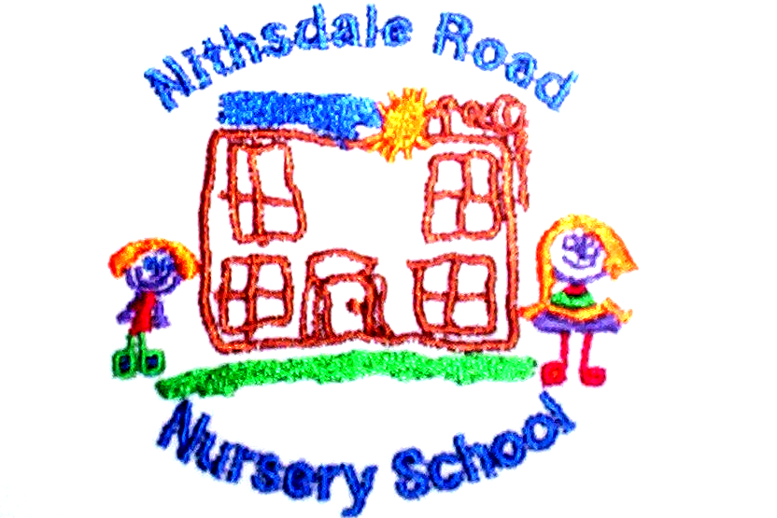

NITHSDALE ROAD NURSERY SCHOOL
264 NITHSDALE ROAD
GLASGOW
G41 5LB

TEL:0141 427 1896

The Quick Guide to Healthy Eating and Oral Health for your child

- Encourage your child to eat five
different types of fruit/vegetables every day in child size portions.

- Include bread, cereal, potatoes, rice, pasta or chapatti as part of every meal.

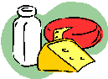
- Your child should have some milk, cheese and/or yoghurt three times a day.

- Meat, fish, chicken, eggs, beans or pulses should be included at lunch and dinner.

- Limit the number of times, and the amount of sugary and fatty foods your child eats, particularly sweets and snacks.

- Give your child water and milk for drinks, especially between meals.

- Brush your child’s teeth in the morning
and before bed with a fluoride toothpaste (1000ppmF).

- Always ask your pharmacist for sugar-free varieties of prescribed and over the counter medicines for your child.

- Take your child to visit the dentist at least once a year.

Yours sincerely,



Annemarie Miller
HEAD OF NURSERY

