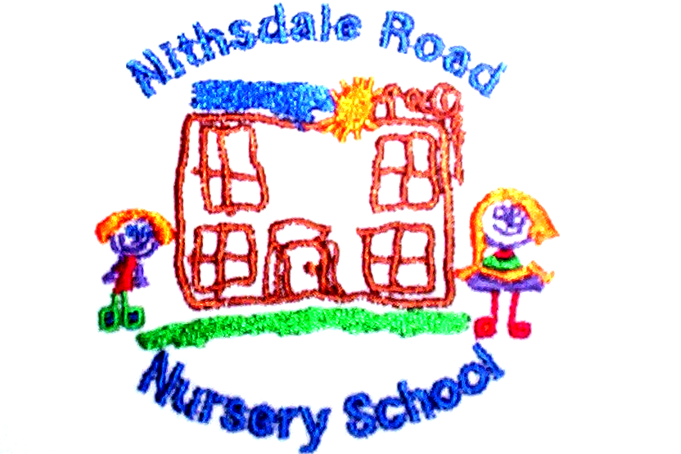


NITHSDALE ROAD NURSERY SCHOOL

264 NITHSDALE ROAD

GLASGOW

G41 5LB

TEL: 0141 427 1896

READ TOGETHER

Dear Parent,

The children are encouraged to borrow a book every Friday from the school library.
Please take time to read the story to your child.

It would be helpful if you could discuss:

- The front cover of the book – ask your child “What is the story about?”

- The title and explain what an author and an illustrator do.

- Point to the words as you read, drawing attention to some letters.

- During the story, ask your child what he/she thinks will happen next.

- Encourage your child to turn the pages.

- At the end of the story discuss some of the characters – what they did or what happened to them – ask your child if he/she would have done the same – if not, what would he/she have done – did he/she enjoy the story?

- Give as much encouragement as you can to your child and share all kinds of books as often as you can.

- Please remind your child to return his/her book and book bag to the nursery on or before each Friday.

Yours sincerely



Annemarie Miller
HEAD OF NURSERY

