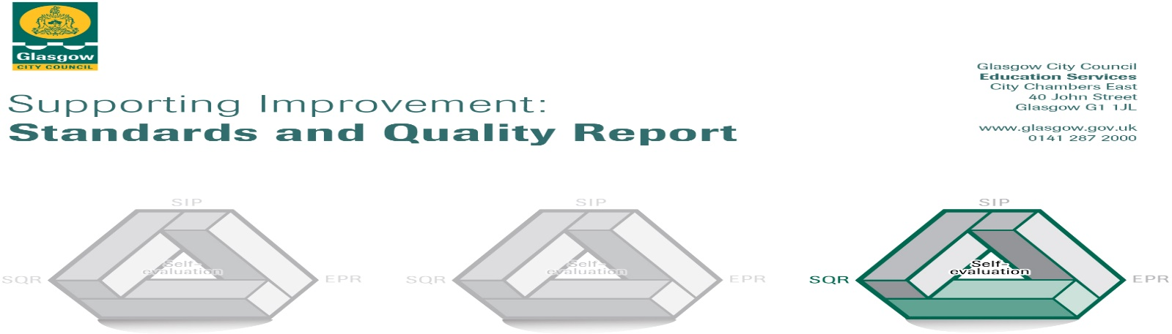

The summary report is provided for parents/careers and partners to outline our achievements this session and our priorities for next session. Throughout this session we have taken forward our priorities as detailed in our school improvement plan. Through our processes of self-evaluation, we have identified how we can improve outcomes for our children and young people.

Our achievements and improvements this year.
Our hope and aim is to make Nithsdale Road Nursery School a place where children are valued as individuals and a place where families feel welcome and included. Our highly committed and experienced staff team will always work hard to ensure that we create a learning environment that is interesting and motivating for all children and ensure that learning is at the heart of what we do. We will strive to ensure that every child is safe, healthy, achieving, nurtured, active, respected, responsible and included. Each year we strive to improve the education and care we provide. This report tells you how well we are doing how well we have improved and what we plan to work on next year. Thank you for your continue support and we will ensure that Nithsdale Road Nursery continues to provide high quality early learning and child care and as Head of Nursery I will continue to provide strong leadership that will ensure best service delivery and continue to have a positive impact on the outcomes for children and their families.
We would like to highlight the following improvements/achievements:

- Key Developments (leadership of change) QI 1.3
Our vision, value and aims has been reviewed and refreshed to underpin the current work of the setting and ensures that all staff shares the responsibility for creating a positive and caring ethos. There is a genuine commitment from all staff to share our vision with our families and ensure that we continue to deliver high quality early learning and childcare. This year we asked everyone to give us a few words to describe us. As a result, we have a new infographic created. A commitment to quality childcare and early learning remains at the heart of what we do and there is in place a genuine interest from all staff in children’s learning and development and this leads to a clear understanding by all to the needs of the nursery and its community.

- Developments in learning, teaching, and assessment Q1 2.3
Almost all our children are engaged and motivated in their learning. Our playrooms, routines and pace of day ensure that there is an exceptionally good balance of spontaneous play and planned play opportunities. Children’s learning experiences are captured in individual learning folders, digital book creator and learning walls. Very good use of photographs allows parents and carers to see visible progress throughout the year. Staff make very good use of digital trackers to capture children’s improvements in literacy and numeracy, and these are used to identify progress in children’s learning.

Progress in promoting well-being equality and inclusion QI 3.1

Very good use of bilingual staff ensures that almost all children who have English as additional language are well support. The introduction of Think Equal Program provides opportunities for almost all children and staff to work together to talk about their feelings, share their experiences and celebrate themselves as individuals. The Program is delivered using books and as a result we saw the majority of children make good progress in their literacy skills. Specifically in the areas of talking and listening.
All children who require additional support have robust systems in place to ensure their needs are being met and reduce barriers to learning. Robust systems are in place to ensure the welfare and safety of all children is understood by staff.

Progress in children’s learning /raising attainment and recognising achievement QI 3.2
Almost all children are participating in Think Equal Program and because of this we are seeing children make very good progress in the areas of literacy and health and well-being. The nursery’s reputation for delivering the program is growing and advice has been sought from several nurseries across the city on the best practice guidance. Head of Nursery has met with the Scottish Directors of Think Equal and has been able to offer advice and support in how best the program is delivered throughout the city. As a result of a review of personal plans all children now have more robust personal planning in place ensuring that vital information is shared and this helps influence individual planning.

Here is what we plan to improve next year.
- We will continue to work closely with other education establishments in our area which should ensure community partnerships are well established within our Learning Community
- Current guidance will be used to inform practice ensuring best outcomes for all children based on an ethos of inclusion and nurture.
- We will collaborate closely with our local schools to ensure our transitions are effective and successful. Our children will be well prepared for leaving nursery and on to school.

How can you find out more information about our school?
Please contact us directly if you require further information or if you wish to comment on the report.

The contact e-mail address is:headteacher@nithsdaleroad-nursery.glasgow.sch.uk

Our telephone number is: 0141 427 1896.

Our school address is: 264 Nithsdale Road Glasgow G41 5LB.

Further information is available in newsletters, the school website, and the school handbook.

