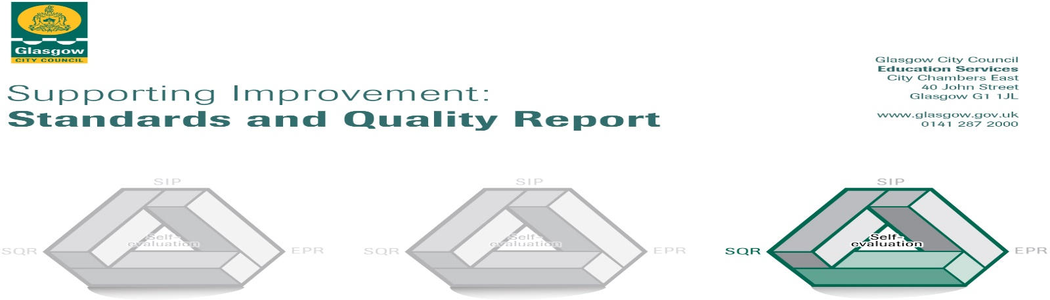

The summary report is provided for parents/careers and partners to outline our achievements this session and our priorities for next session. Throughout this session we have taken forward our priorities as detailed in our school improvement plan. Through our processes of self-evaluation, we have identified how we can improve outcomes for our children and young people.

Our achievements and improvements this year.
Our hope and aim is to make Nithsdale Road Nursery School a place where children are valued as individuals and a place where families feel welcome and included. Our highly committed and experienced staff team will always work hard to ensure that we create a learning environment that is interesting and motivating for all children and ensure that learning is at the heart of what we do. We will strive to ensure that every child is safe, healthy, achieving, nurtured, active, respected, responsible and included. Each year we strive to improve the education and care we provide. This report tells you how well we are doing how well we have improved and what we plan to work on next year. Thank you for your continue support and we will ensure that Nithsdale Road Nursery continues to provide high quality early learning and child care and as Head of Nursery I will continue to provide strong leadership that will ensure best service delivery and continue to have a positive impact on the outcomes for children and their families.
We would like to highlight the following improvements/achievements:

- Key Developments (leadership of change) QI 1.3
The vision, value and aims have been refreshed to reflect changes in staff and our response as a whole team as how we continue to negotiate our way through the pandemic. There remains a strong culture of improvement where all staff has leadership responsibilities and are committed to deliver practice to the highest quality. There is a clear and shared understanding of the needs of our children and families with current thinking in high quality early learning and childcare at the heart of what we do. All staff show a strong commitment to self- development and personal improvement with high uptake in training opportunities.

- Developments in learning and teaching and assessment Q1 2.3

Our very good staff/child r ensure that all of our children are well supported to make decisions, exercise choice and take responsibility for their own learning. Effective use of staff’s bilingualism offers support to children and families and ensures that home language is supported. All staff ensures that our learning environment is enabling, rich, varied, nurturing and safe. As a result our children are motivated and stimulated within our playrooms contributing to their learning and engagement. Careful consideration is given to resources, pace of day and sensitive interaction and very good use is made of high- quality observations ensuring we are meeting the needs of all our children. Very good use has been made using literacy and Numeracy Trackers enabling staff to support children’s progress in these key curricular areas.

- Progress in promoting well-being equality and inclusion QI 3.1

Our commitment to creating a supportive ethos where children and families are welcomed and valued remains a key priority for the nursery. We are a diverse and multi- cultural establishment where individual skills, talents and achievements are celebrated and recognised. Bilingual staff and our EAL Teacher have established robust programmes to support our bilingual learners and children who may have English as an additional language. Well- being Assessment Plans are in place for any children who may require additional support. Relationships with fellow professionals from Education and health remain very good and our robust school transition programme ensures a high number of children leave here well prepared for the move to school. We will continue to promote wellbeing by adopting an ethos based firmly on nurturing approaches as we continue to support our nursery community negotiate its way through this pandemic.

- Progress in children’s learning /raising attainment and recognising achievement QI 3.2
Our programmes around mathematics, early language, communication and health and well- being are well thought out and delivered to consistently high standard. Our outdoor space has been invaluable this year as we have been able to be outside almost all of the time allowing us to be safe. Children are able to mix freely and negotiate friendships, interactions and develop valuable social skills. Learning for sustainability has a high profile with the nursery receiving many awards for i’s continues work supporting children in their development of a wide range of skills and knowledge pertaining to nature and the environment. The nursery was one of eight schools in Glasgow to renew their Green Flag status with the award of our fourth green flag. This is an outstanding achievement for our Eco committee to achieve such an award in a time of unprecedented adjustment and change to education caused by the Coronavirus pandemic (GCC) The nursery has already started its journey to become involved in COP26 with inclusion of our work in the launch video.

Here is what we plan to improve next year.
- Our learning is supported and enhanced by a range of digital technology and approaches. This will be achieved by having a clear plan for developing staff and children’s digital skills in using and exploring digital technologies. This plan will move at a steady pace to be inclusive of all stages of learner.

- Children will be provided with the support to develop their skills for life and learning and an awareness of the world in which they live and grow.

- Using an ethos based firmly on a nurturing approach we will support our nursery community repair, recover and rebuild. This will be managed at a sustainable pace with regular opportunities available for professional dialogue and discussion resulting in positive outcomes for children with particular emphasis on the support and promotion of wellbeing.

How can you find out more information about our school?
Please contact us directly if you require further information or if you wish to comment on the report.

The contact e-mail address is:headteacher@nithsdaleroad-nursery.glasgow.sch.uk

Our telephone number is: 0141 427 1896

Our school address is: 264 Nithsdale Road Glasgow G41 5LB

Further information is available in: newsletters, the school website, and the school handbook

