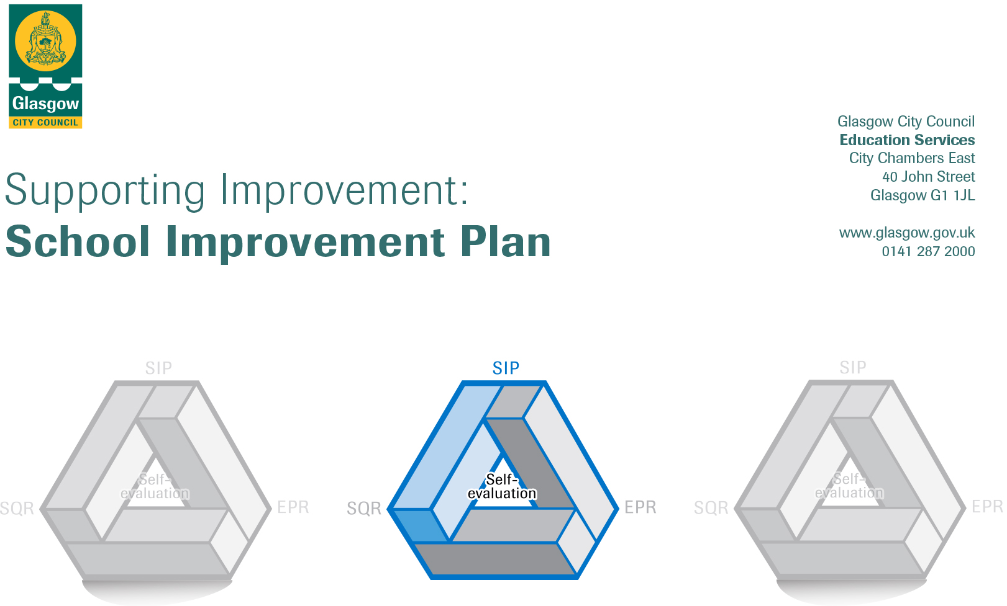

Establishment |  | Nithsdale Road Nursery School
Head of Establishment |  | Annemarie Miller
Area/Local Improvement Group |  | South Lig 2
Head of Service |  | Donnie MacLeod
Area Education Officer/  Quality Improvement Officer |  | Sharon Constable

CONTENTS
1. Vision, Values and Aims
2. Summary of Self-Evaluation Process / Priorities for Improvement in the current session
3. Action Planning

Action Plan Summary for Stakeholders

1. Our Vision, Values and Aims
Our Vision at Nithsdale Road Nursery School is to work in partnership with parents, cares and the community to offer a safe, secure, caring, healthy, respectful, inclusive, stimulating learning environment where each child achieves their full potential.

Our Values at Nithsdale Road Nursery School are the characteristics that we believe are essential for lifelong learning:
Children need to be able to adapt to different experiences and achieve emotional wellbeing. They need to take responsibility, recognise and manage their own feelings and understand the feelings of others, have a sense of independence and self-worth, form and maintain positive, mutually respectful relationships with others, be able to solve problems and make informed decisions and have a sense of purpose and goals for the future.

2. Summary of our self-evaluation process.
Our self- evaluation focuses on key aspects of our children’s successes, achievements and well-being. An effective system is in place to monitor the quality of the work of the nursery and to gather the views of the staff, parents, children and other stakeholders. Staff work together to evaluate provision and together we make improvements and changes where needed. There is focus on continuing improvements to learning and teaching as well as improvements in achievements of all children. Strengths and areas for improvement are clearly identified. Our self- evaluation draws on a wide range of evidence. Staff are reflective practitioners and share good practice. Complete review undertaken using How Good is Our Early Learning and Child Care. This is reviewed yearly.

Strengths identified:
- Relationships
- Environments
- Nurture

Priorities for development:
1: Information Technology/Digital Learning

2: Learning for Sustainability (COP26)

3:Ensuring Wellbeing, equality and Inclusion

3. Action Planning

No. | Quality Indicator | Priority
1 | 3.3 – Theme 3 Developing Digital Skills  CS 1.30 | Our learning is supported and enhanced by a range of digital technology and approaches. This will be achieved by having a clear plan for developing staff and children’s digital skills in using and exploring digital technologies. This plan will move at a steady pace to be inclusive of all stages of learner.

Tasks to achieve priority | Timescale  and checkpoints | Evidence of Impact > (data, observation, views)
Whole staff questionnaire to establish stages of digital knowledge. | August 2021 | Information gathered will inform next step.
From questionnaires run a series of twilight courses to inform new learners. | September 2021 | Staff will have Increased confidence in equipment.
Whole staff look at which 3 apps/technologies we will all be using (including Seesaw) and how the children will be accessing these. | Early October 2021 | Staff all working together will be able to compare children’s progress in learning.
From apps/technology chosen run a series of twilights to introduce app and how to use it. | November 2021 | Staff will have increased confidence in chosen technology and use it to its optimum.
Chosen apps/technology are used by staff and children in learning both indoors and outdoors. | Ongoing | Staff and children are working together in different settings to enhance learning using technology.
Staff come together to highlight difficulties and pinpoint success in impact of technologies on learning. | Ongoing with a detailed meeting in March 2022 to introduce new apps/technologies dependent on outcome. | There will be a group understanding of the way forward and of the stages achieved.
Apple Teacher qualification to be worked on as staff feel confident. | Ongoing | Staff feel able to work on and complete qualification.
Application for the Digital Schools award. | March 2022 | Whole nursery approach and enthusiasm for going forward in application for award.

Staff leading on this priority – including partners | Resources and staff development
Mary Cumming – DLOL/TL  GCC | iPads, Apple Teacher course, selection of apps/technologies including Seesaw  Series of twilight courses for staff to be held inhouse.

No. | Quality Indicator | Priority
2 | 2.2 - Theme 4  CS 1.25 | Children will be provided with the support to develop their skills for life and learning and an awareness of the world in which they live and grow.

Tasks to achieve priority | Timescale  and checkpoints | Evidence of Impact > (data, observation, views)
Set-up the Eco Committee and identify knowledge and understanding of climate action including the introduction to our pledge. | October 2021 | Information gathered will inform next step.
Using GCC chosen Glasgow goals for COP26 focus on climate action – litter and three Rs (reuse/reduce/recycle) | June 2022 | Staff and children will become increasingly more confident in a variety of methods in which we can reuse/reduce/recycle materials such as food waste/paper/plastic.
Staff and children to participate in regular community litter picks. | Ongoing | Children become aware of the importance of disposing of waste in an appropriate manner.
Promote further biodiversity in particular wildlife within the nursery grounds – linking with application for fifth Green Flag | June 2022 | Staff and children will develop their knowledge and understanding of the wildlife that can be encouraged to settle within various forms of habitat within the nursery grounds.

Staff leading on this priority – including partners | Resources and staff development
Julia Gunn and Emma Hobbs and Eco committee  All staff  Eco Schools Scotland  Glasgow City Council  Scottish Government | Garden materials, Birdboxes, bird hotels.  Access to COP26 Learning Materials

No. | Quality Indicator | Priority
3 | 3.1 Theme 1  CS 1.29 | Using an ethos based firmly on a nurturing approach we will support our nursery community repair, recover and rebuild. This will be managed at a sustainable pace with regular opportunities available for professional dialogue and discussion resulting in positive outcomes for children with particular emphasis on the support and promotion of wellbeing.

Tasks to achieve priority | Timescale  and checkpoints |  | Evidence of Impact > (data, observation, views)
Covid-19 recovery plan agreed and in place. | On-going following Govt and local authority guidance. |  | Remits, roles and responsibilities are clear to all staff. Whole team approach. It will be under constant review.
Nurturing Principles and Approaches are embedded in our everyday practice. | Sept 2021 |  | All staff use a nurturing approach to support the development of wellbeing.
Policy and Risk Assessment review | Ongoing from August 2021 |  | Our policies are accurate and up to date to support children, families and staff in the current climate.
Up to date training on ACES/Resilience | October 2021 |  | Learning and teaching approaches are understood and used to promote resilience and wellbeing.
Make good use of PATHS/Circle Time | Nov 2021 | Children will have opportunities to practice the language of emotions to support their emotional wellbeing.
Work closely with families | On going | Our families are aware of and understand our nurturing approach and are able to use this to support their own families.

Staff leading on this priority – including partners | Resources and staff development
Head of Establishment  Team Leaders  CDOs  Education Psychologist  Glasgow City Council  Scottish Government | Current documentation: Applying Nurture as Whole School Approach. Realising the Ambition. Care Standards.  Opportunities for all staff to develop their policy review and writing skills.  Team Leaders development of understanding and developing Risk Assessments  Resilience Video to explore ACES movement.  All staff will develop their research skills and use knowledge gained to improve outcomes for children whilst further developing personally and professionally.  Health and Social Care Standards: “I am supported to be emotionally resilient, have a strong sense of my own identity and well-being, and address any experiences of trauma or neglect (Standard 1.29)

