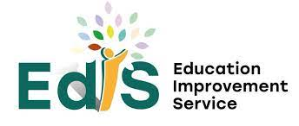


Session: 2025-26

Establishment name | NITHSDALE ROAD NURSERY SCHOOL
Learning Community | GOVAN/BELLAHOUSTON
Link Officer / Area ELC Manager | ANGELA McC0NALOGUE
Head of Service / ELC | HEATHER DOUGLAS

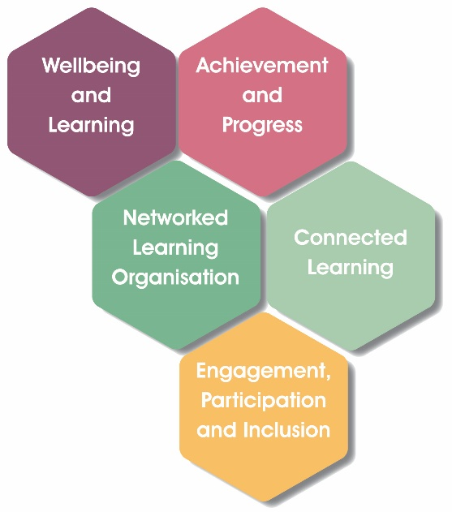
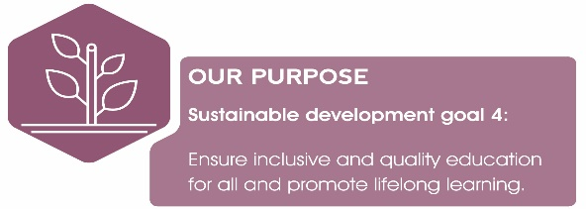

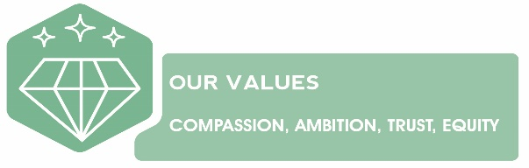

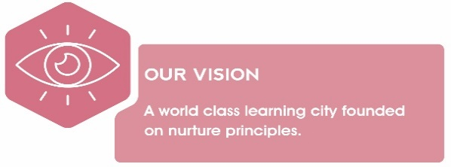

EVALUATIVE STATEMENTS
Quality Indicator 1.3 Leadership of Change
How well are you doing?  Evaluative statements describing the impact of improvement actions detailed in your current Improvement Plan (measured against expected outcomes) | How do you know?  Describe the evidence you have gathered which details impact on pedagogy and learners | What are you going to do now?  What are your next steps/ priorities in this area?
All Children and families benefit from a shared vision, values and aims and objectives that positively inform practice  As a result of a well-developed culture of distributed leadership all staff can exercise initiative and take lead roles.  Self- evaluation is utilised and viewed by all staff and service users as a process that leads to improvement. Recent Care Inspection (Aug 24) Identified some gaps in monitoring systems.  As a result of effective community partnerships within the learning community there is a strong culture of collaborative leadership for senior leaders. | Vision, values and aims reviewed May 2025 by gathering staff, parent and children’s views via questionnaire.  All staff have a lead role in key areas such as Eco work (LFS), digital learning, health and wellbeing, Language and Communication and family learning. There is a high uptake of training opportunities indicates a strong level of commitment to personal and professional development.  Regular staff meetings ensure that staff are kept up to date and informed of Improvement priorities (challenges and missions) Improvement documentation is shared with parents digitally. December check points in place for review.  Triangulation of evidence gathered is more evident and manageable. New monitoring systems in place and led by SMT.  Targeted interventions and training in place for senior staff as outlined in learning community timetable. | Infographic to be created using the information gathered from our families, staff and children.  Staff PRD sessions will ensure staff skills and areas of expertise are being supported through SMT one to one support and training opportunities.  Review monitoring systems and ensure that self-evaluation is evidence based. Gradual transfer from HGIOELCC to ‘A Quality framework for the early Learning and Childcare Sectors for quality audit purposes  Staff identified to lead key roles such as moderation and Transition
Using the descriptors from HGIOS 4, how do you evaluate your progress within this Quality Indicator? (Please Highlight)

Unsatisfactory Weak Satisfactory Good Very Good Excellent
EVALUATIVE STATEMENTS
Quality Indicator 2.3 Learning, Teaching & Assessment
How well are you doing?  Evaluative statements describing the impact of improvement actions detailed in your current Improvement Plan (measured against expected outcomes) | How do you know?  Describe the evidence you have gathered which details impact on pedagogy and learners. | What are you going to do now?  What are your next steps/ priorities in this area?
Almost all children are motivated and show high levels of engagement. Playrooms are well organised ensuring children’s interest are sustained for long periods.  All staff uses Literacy and numeracy trackers effectively to gather assessment information and ensure that children’s progress is captured at key points.  All children’s learning and achievements are well captured through a variety of mediums and ensure children’s progress is up to date and accurate.  Planning intervals are flexible and take into consideration all learners to ensure learning needs are being met.  Progress of individuals including those children who face challenges and require additional support is carefully monitored and tracked. | All staff regularly rotate playrooms and resources are renewed and replenished based on children’s interest.  All staff take time each term to review digital trackers to monitor progress.  Children’s learning experiences are captured in individual learning folders, digital book creator and learning walls. Very good use of photographs allows parents and career to see visible progress throughout the year.  Planning is monitored using 7 principles of the curriculum. Staff capture and record children’s key learning.  ASN group is in place to ensure there is a clear understanding of individual learning needs. The group meet monthly and is made up with a variety of staff including SMT, CDOs and support for learning workers. | Carefully observe learning environments to ensure that all children are being considered particularly in the areas of emotional and social development  SMT will take a more robust approach to monitoring children’s progress to ensure tracking is more accurate.  Staff to be given more time off floor to evaluate learning and ensure children’s progress is recorded and monitored more accurately  Make better use of inclusion frameworks to assess and support children who have additional support needs.
Using the descriptors from HGIOS 4, how do you evaluate your progress within this Quality Indicator? (Please Highlight)

Unsatisfactory Weak Satisfactory Good Very Good Excellent

EVALUATIVE STATEMENTS
Quality Indicator 3.1 Wellbeing Equality & Inclusion
How well are you doing?  Evaluative statements describing the impact of improvement actions detailed in your current Improvement Plan (measured against expected outcomes) | How do you know?  Describe the evidence you have gathered which details impact on pedagogy and learners. | What are you going to do now?  What are your next steps/ priorities in this area?
Very good use of bilingual staff ensures that almost all children who have English as additional language are well support  The introduction of Think Equal Program provides opportunities for almost all children and staff to work together to talk about their feelings, share their experiences and celebrate themselves as individuals.  All children who require additional support have robust systems in place to ensure their needs are being met and reduce barriers to learning.  Robust systems are in place to ensure the welfare and safety of all children is understood by staff | Urdu/Punjabi are the dominant languages in use and 4 staff speak these languages offering additional support to children and their parents thus supporting transitions and the use of mother tongue.  Big books created showcasing the Think Equal Program. Evaluation of program carried out by Team Leader and CDO to assess impact of program. Head of Nursery has worked with other establishments to share practice and implement program.  Well-being Assessment Plans (WAPS) are in place for all children who need additional support. These are reviewed regularly by SMT, keyworkers and parents  Review of welfare and safety including child protection guidance is shared with all staff during august inset. | Develop more effective ways to communicate with parents to ensure information is shared particularly with those children who have communication challenges.  Key staff will monitor Think Equal Program and adjust as and when necessary. Key staff will continue to support the wider community in delivering the program.  There will be an improved distribution of leadership responsibilities to support learners who may require additional support. Introduction of new processes (WAP, Nurture Policy and revised inclusion policy)  New procedures to be reviewed August inset
Using the descriptors from HGIOS 4, how do you evaluate your progress within this Quality Indicator? (Please Highlight)

Unsatisfactory Weak Satisfactory Good Very Good Excellent
EVALUATIVE STATEMENTS
Quality Indicator 3.2 Raising Attainment & Achievement
How well are you doing?  Evaluative statements describing the impact of improvement actions detailed in your current Improvement Plan (measured against expected outcomes) | How do you know?  Describe the evidence you have gathered which details impact on pedagogy and learners | What are you going to do now?  What are your next steps/ priorities in this area?
All staff make very good use of literacy and numeracy trackers to inform them of children’s progress and identify next steps in their learning.  All children have access to opportunities to move freely indoors and out and from playroom to playroom. As a result of this children are independent and confident in making choices and decisions about their preferred learning style.  Programmes around mathematics, early language, communication and health and wellbeing are well thought out and delivered to a high standard by all staff. Careful consideration is given to pace of day and there is very good balance between free play and planned experiences  Most children are making good progress in developing their digital skills and are confident using a variety of digital learning tools such as iPad, spheros and quebeto.  As a result of learning for sustainability having such a high profile almost all out children are developing a wide range of skills and depth of knowledge relating in this key area. | All children have an individual digital tracker for literacy and numeracy, and these are updated regularly by keyworkers. This information is shared as art of Transition Programs with local school.  The nursery offers a unique outdoor space with gardens and playground space. There are opportunities for all children to be outdoors daily. Free flow lunch offers a relaxed and calming eating experience where independence and choice are encouraged and supported by all staff.  All playrooms offer opportunities for all children to develop skills in the three key areas. Playrooms are well resourced and organised with and are organised into curricular areas (Imaginative, Creative, STEM and Curiosity)  Leader of Early Learning has supported senior staff to support ensure an effective monitoring system is in place to track literacy and numeracy progress.  Eco group is established, and children and staff are highly visible in the setting and within the community with local litter picks. All children have planted potatoes and used these to cook. | Monitoring of trackers and how they are linked to children’s learning journals to be more robust and moderated by SMT  Continue to monitor outdoor spaces and how they are being accessed by all children.  Continue to monitor and ensure resource are suitable to children’s needs and interests.  Leader of Early Learning to support staff have a clearer picture of learners who are developing, progressing and consolidated in their learning.  Achieve 6th Green Flag (Summer 25)  Work towards our 6th Green Flag (May 25)
Using the descriptors from HGIOS 4, how do you evaluate your progress within this Quality Indicator? (Please Highlight)

Unsatisfactory Weak Satisfactory Good Very Good Excellent

EVALUATIVE STATEMENTS
Optional Additional Quality Indicator: QI
How well are you doing?  Evaluative statements describing the impact of improvement actions detailed in your current Improvement Plan (measured against expected outcomes) | How do you know?  Describe the evidence you have gathered which details impact on pedagogy and learners. | What are you going to do now?  What are your next steps/ priorities in this area?
Using the descriptors from HGIOS 4, how do you evaluate your progress within this Quality Indicator? (Please Highlight)

Unsatisfactory Weak Satisfactory Good Very Good Excellent

