


NEWSLETTER

SEPTEMBER 2021



Nithsdale Road Nursery School, 264 Nithsdale Road,
Glasgow, G41 5LB TEL: 0141 427 1896
www.nithsdaleroad-nursery.glasgow.sch.uk


Dear Parents

Welcome
I would like to say welcome back to all of our children and families who attended last year and a warm welcome to our new children and families. I hope that you will enjoy your time here at Nithsdale Road and will always be made to feel welcome and a part of our nursery. As parents you are your child’s first educator and we should never underestimate the important job that you all do. Your opinion is very important to me and I believe that we cannot deliver the best service without your help. If there are any aspects of the service that you feel we could improve on or indeed if there are aspects of our service that you particularly like, please let us know, headteacher@nithsdaleroad-nursery.glasgow.sch.uk

Groups and Staff
Our focus for the beginning of term is all about getting to know each other, learning about routines and developing relationships. The children have now all been grouped and have a named keyworker:

Red – Carly McMillan/Ammara Afzal/Liz Trainer
Blue – Julia Gunn/Amina Alam
Green – Emma Hobbs/Ashley Sharkey (temp)
Yellow – Noreen Ejaz/Angela Keegan

Support for Learning – Megan Ross and Nadia Khan

Team Leaders are: Mary Cumming and Tracey Docherty. Mary is our first aider and is responsible for the management and administration of medicines. Tracey is responsible for pupil support and, along with myself, is responsible for children’s Wellbeing Assessment Plans. Mrs Therese Moore is our EAL Teacher and is here every Monday and Tuesday for all children but with a key focus to support children who may not have English as their first language. Several staff members are bilingual and are happy to work with any families who may require support with translation. (Urdu/Punjabi)
We have two pupil support for learning workers who are with the children over lunch times as well as other caring responsibilities.

Child Protection:

Whilst it is the responsibility of all for the welfare and safety of the children, as Head of Nursery, I am the named child protection coordinator and I am responsible for any child protection issues that may arise.



Promoting Positive Behavior

All staff have high expectations on how children behave at nursery and this is supported by the use of Golden Rules and our PATHS Programme.
You will soon receive a copy of our Golden Rules. Please talk to your child about the rules and how they apply both at home and in nursery:

- We are gentle.
- We are kind and helpful.
- We listen.
- We are honest.
- We work hard.
- We look after everything.

Our Golden Rules are displayed around the nursery.

Managing Covid-19 within the nursery

- A rigorous approach to environmental cleaning has been implemented to prevent the spread of the virus, in line with the arrangements set out by local and Scottish Government guidance.
- Carol our Janitor has now extended her hours and will take on the role of day cleaner. This ensures that the nursery is cleaned thoroughly between sessions and throughout the day.
- All toys and equipment will be cleaned by staff between sessions
- Consideration should be given to limiting the extent to which children’s belongings are brought into nursery.
- Children and staff will clean their hands with soap and warm, running water or sanitizer, when they arrive at nursery, return from breaks, change rooms and before and after eating
- There is provision of adequate hand-washing or sanitising facilities throughout the building.
- Arrangements in place to support young children and those with complex needs who may need assistance
- Children, young people and staff should be encouraged to catch coughs/sneezes with tissues or elbow
- Where possible parents should use face coverings in and around the building.
- PPE is on site and staff have access to gloves, aprons, masks and visors should they be required in the event of a child needing changed or first aid treatment required.
- All playrooms/meeting rooms will be ventilated and windows and doors where appropriate will be opened regularly.
Staff have access to Lateral Flow tests and these are carried out twice weekly

If your child becomes ill? 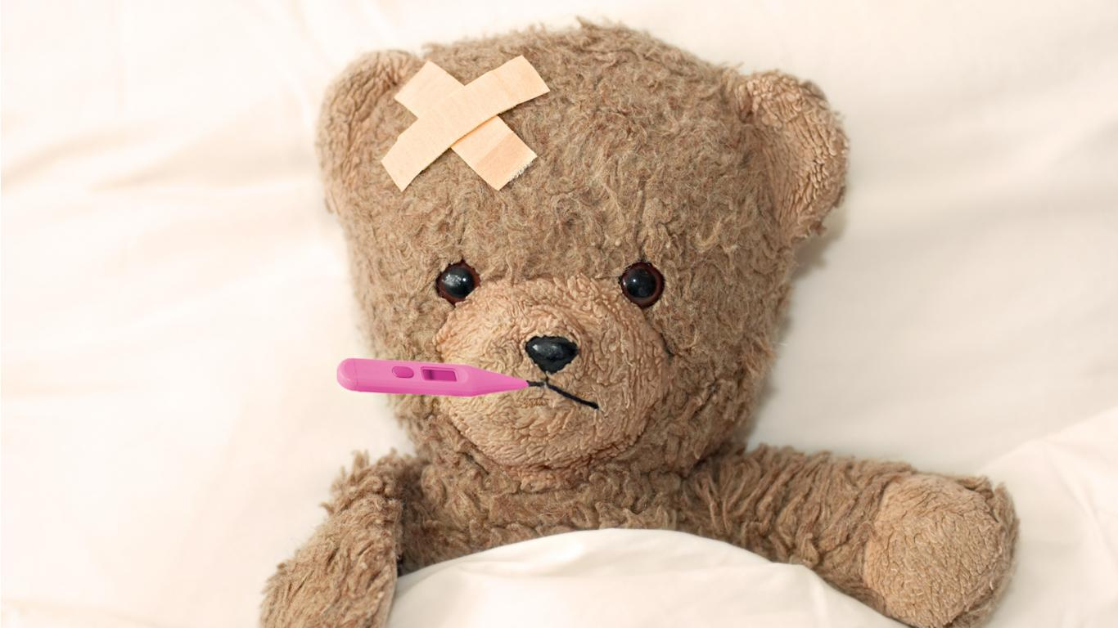

The whole nursery community should be vigilant for the symptoms of COVID-19. The most common symptoms are:
- New continuous cough
- Fever/high temperature
- Loss of, or change in, sense of smell or taste.
It is important that your child should not attend nursery if symptomatic, but instead parent/carers should follow guidance on NHS inform website and from Test and Protect if you are identified as a close contact.

If your child becomes ill whilst at nursery they will be isolated in a well -ventilated room and parents will be contacted for immediate pick up. This should be a member of their household and not a neighbour/friend or relative who does not live with them.
Please call the nursery if your child is unwell for any other reason.



Communication
It is important that we get the email address and mobile telephone of the main contact for your child. Group call is the system we use to contact you. There is an app available called Xpressions. I have enclosed a link on how to access this:
http://parents.groupcall.com/
Mary is our Digital Leader of Learning and she is happy to support any parent who is may be needing support to download this.

Digital Learning will be a key focus for us this year and we hope to improve how we communicate with you and share children’s progress/successes with you.

You can also get updates on our website www.nithsdaleroad or Twitter @NithsdaleroadNS
0141 427 1896

I am happy to meet with parents at this time at a safe distance if you have any concerns or issues that you might wish to discuss.

Kitchen Update 

Progress with our kitchen/building work is moving at a slower pace than I would have liked. I am hoping that over the next few weeks we begin to see some progress and we can get all of our children in for their full hours. I will keep you up to date as and when I get information.

Nursery Holidays

Sept weekend – Friday 24th Sept
and
Monday 27th September

Inset day – Friday 8th October

October Week – Monday 11th Oct till Friday 15th October

Kindest Regards

Annemarie Miller
Head of Nursery

Best wishes
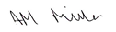

Annemarie Miller
HEAD OF NURSERY

We are being increasingly asked about toilet training advice.
Here are some tips which might help.

Preparing for toilet training:

You can start to get your child ready for toilet training so that it’s not such a surprise when the time comes:

- Say what you’re doing when you change their nappy, “you’ve done a wee, let’s put a clean, dry nappy on”
- Change nappies in the bathroom – this is where we do our toileting business
- Change them standing up
- Encourage them to flush away poo
- Get them to wash their hands after a nappy change
- Look at a book about potty training together, there are lots of books aimed at toddlers with lots of pictures
- Let them see what you do; children learn by copying and they need to see what is normal.

Once you feel they’re ready, buy some pants and go for it! If you’re able, it’s fun for your toddler to be involved and go with you to choose their first underpants.

Don’t confuse them by putting a nappy on when you’re out and about, just take a potty/travel potty with you. If you’re going out and about in the car it’s a good idea to put a towel down on their car seat to protect it.

Accept that there will be accidents. They will forget sometimes but don’t worry. Perhaps set a reminder to yourself to remind them every 30 minutes or so. Allow them to get involved in cleaning up any mess and getting changed.

Praise them every step along the way and you should notice that they’re getting there within a week or two. It’s a good idea to avoid rewarding with sweets but a sticker chart is a great incentive.

Night time Wetting

Toddlers often don’t produce the hormone needed to prevent them producing urine at night time, so they will continue to need nappies overnight for some time. Watch out for a dry nappy when they wake and encourage them to sit on the potty/toilet when they get up. Don’t rush it, you’ll know when they’re ready to start going to bed without a nappy.

Worried about getting started?

If you’ve noticed all the signs that your child is ready, it might be easier than you think. Each child is different but most children will be ready between tow and three years old. Remember to:

- Take it slowly
- Be patient
- Please speak to your Health Visitor for further advice.

Good Luck everyone!

