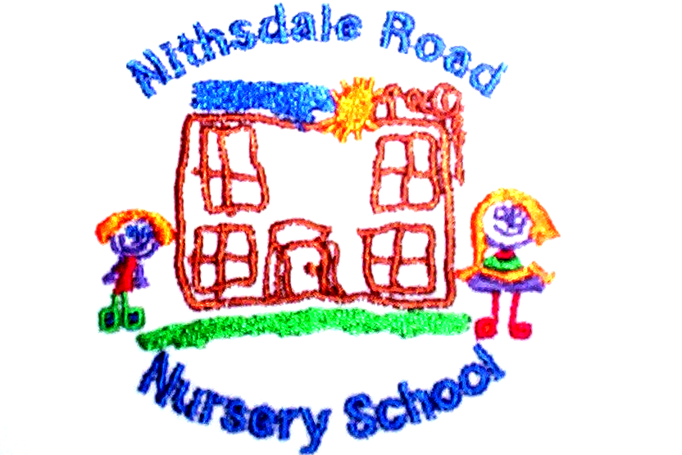


NITHSDALE ROAD NURSERY SCHOOL

264 NITHSDALE ROAD

GLASGOW

G41 5LB

TEL: 0141 427 1896

SUN SMART

Dear Parent

During this term we will be spending more time outdoors.
Hopefully the weather will be bright and sunny.
However I would ask you to ensure that you apply a high factor sunscreen to your child before bringing him/her to Nursery.

It is also advisable to provide a hat for your child to wear. Most effective styles are:

- Broad brimmed hats
- Legionnaire-style hats
- Bucket hats with a brim of at least 6 cms

Baseball hats are not recommended as they do not protect the cheeks, ears or neck.

We will re-apply sunscreen to the full time children before the afternoon session begins.

Yours sincerely,



Annemarie Miller
HEAD OF NURSERY

