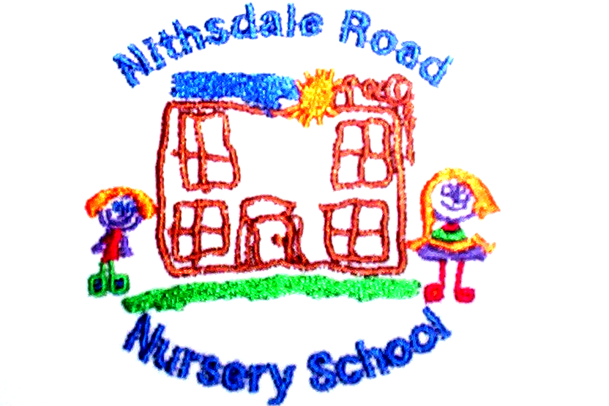


NITHSDALE ROAD NURSERY SCHOOL

264 NITHSDALE ROAD

GLASGOW

G41 5LB

TEL: 0141 427 1896

EARLY LITERACY

A GUIDE FOR PARENTS

A major part of our work with the children is developing Early Literacy Skills. One of the most significant steps in learning to read is a gradual understanding that the visual aspects of print, that is the individual letters and groups of letters correspond to the sounds we hear in speaking.

Children naturally enjoy playing with words and sounds.

In Nursery as well as at home, we can help children in this process by:

- reciting and singing Nursery Rhymes regularly.
- using rhymes of all kinds to make sounds fun.
- Finishing rhymes and correcting “wrong” rhymes e.g. Humpty Dumpty sat on a wall
Humpty Dumpty fell off.
- encouraging the children to dress up and act out their favourite rhymes and stories.
- encouraging the children to make up their own rhyming songs, e.g. 1, 2, 3, 4, here comes Jeanie at the door.
- Make up rhyming words e.g. cat/sat/mat/hat/rat/bat.
- Make up nonsense rhyming words e.g. chelsea/melsea.
- drawing the children’s attention to words that start/end with the same letters and sounds

Number rhymes are also good fun and help children to remember the order of numbers.

We are also:

- using lots of plastic, magnetic and sponge letters as well as alphabet puzzles, wall friezes and alphabet books to encourage the children to learn the names and sounds of letters.

- encouraging the children to recognise his/her own name and its letters.

- drawing attention to the many labels and signs in the environment.

Yours sincerely


Annemarie Miller
HEAD OF NURSERY

